**Q3. Manually configure static IPs on the client devices(like Pc or your mobile phone) and verify connectivity using ping.**

**Control panel -> Network and Internet -> Network and sharing centre -> Change adapter setting**

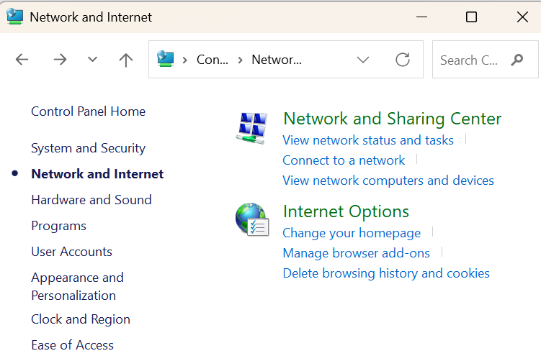

**Choosing the interface(I have chosen Wifi)**

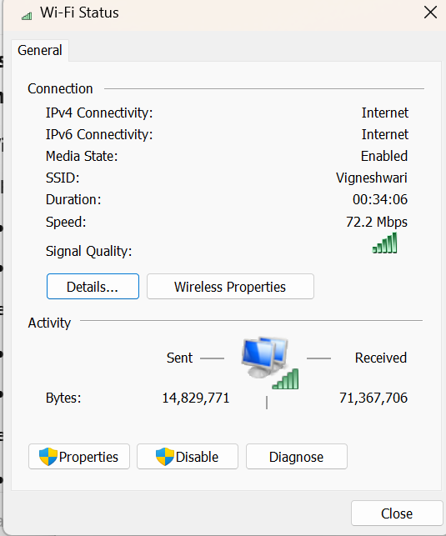

**Change the configuration in (TCP/IPv4) Properties:**

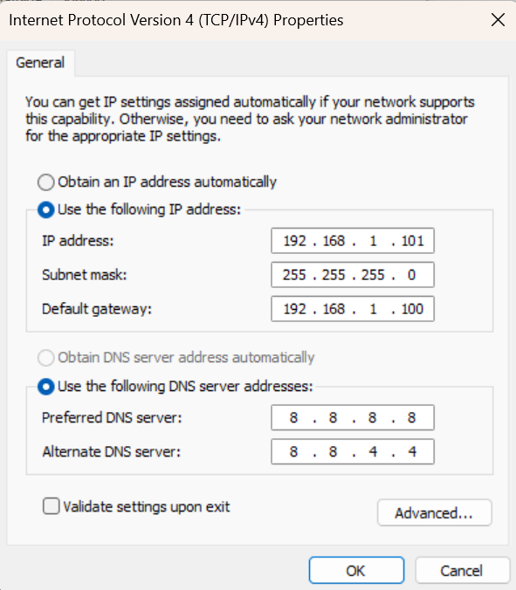

**Checking with ipconfig in cmd.**

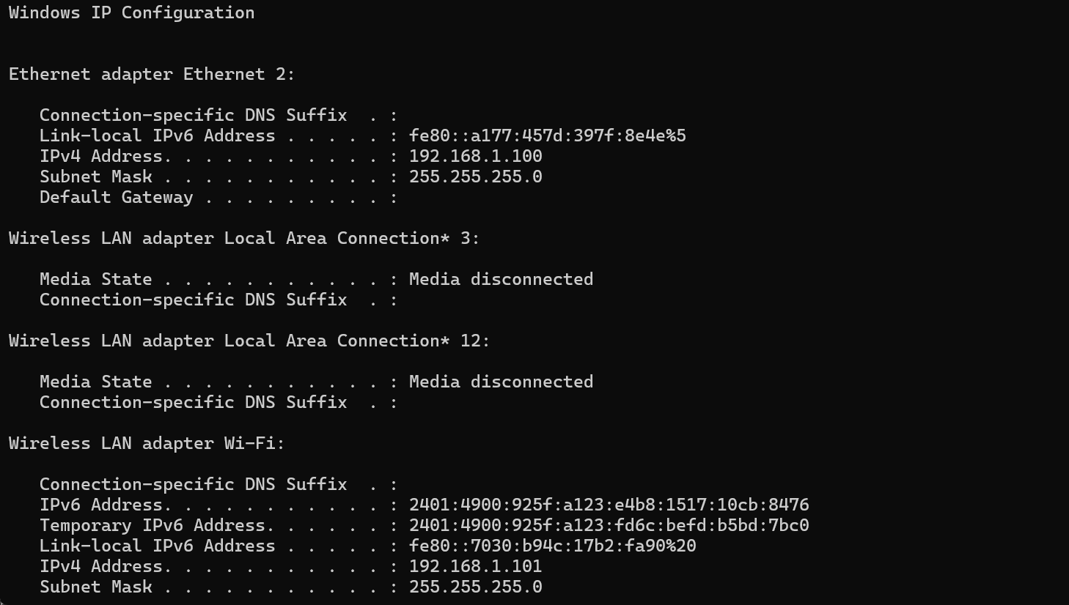

**Pinging the default gateway:**

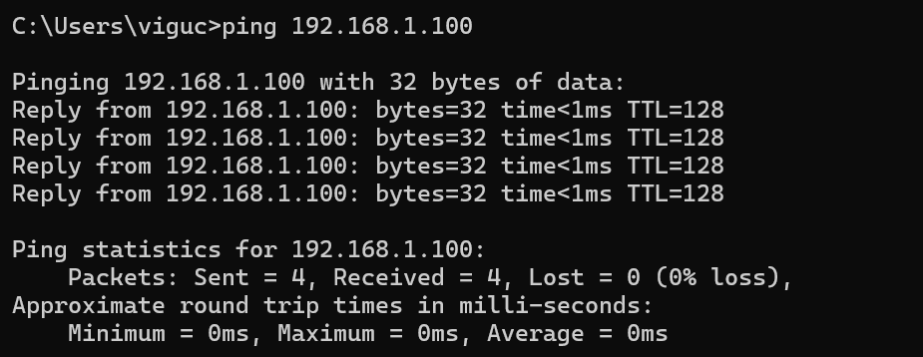

**I have also tried to ping the internet DNS:**

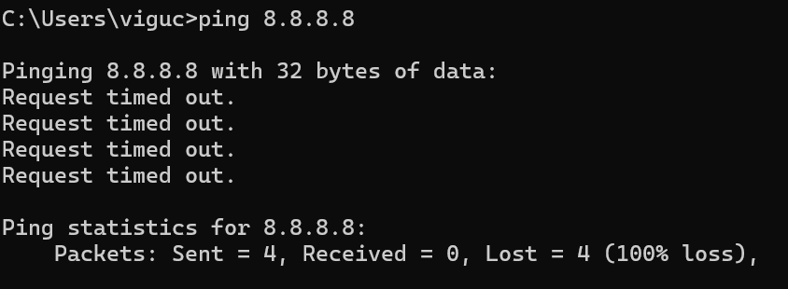

**Pinging the IPv4 address:**

